**Vishal Jha**

**Python Assessment – 30-01-24**

Topics covered:

* Pandas.
* CSV methods to work with CSV files.

Pandas is a python library used for data analysis. It is used to perform operations on files.

In order to perform any operations using pandas, we need to import it.

**Syntax: Import pandas**

Here we used csv.reader() method to read the file content and used for loop to append the data into an empty list and then print it.

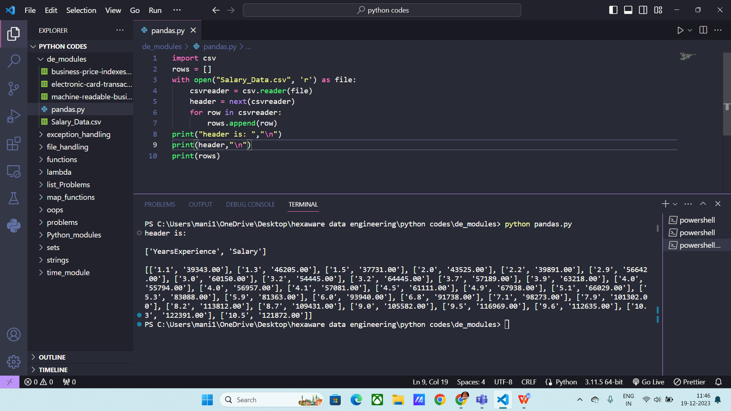

Using readlines in pandas:

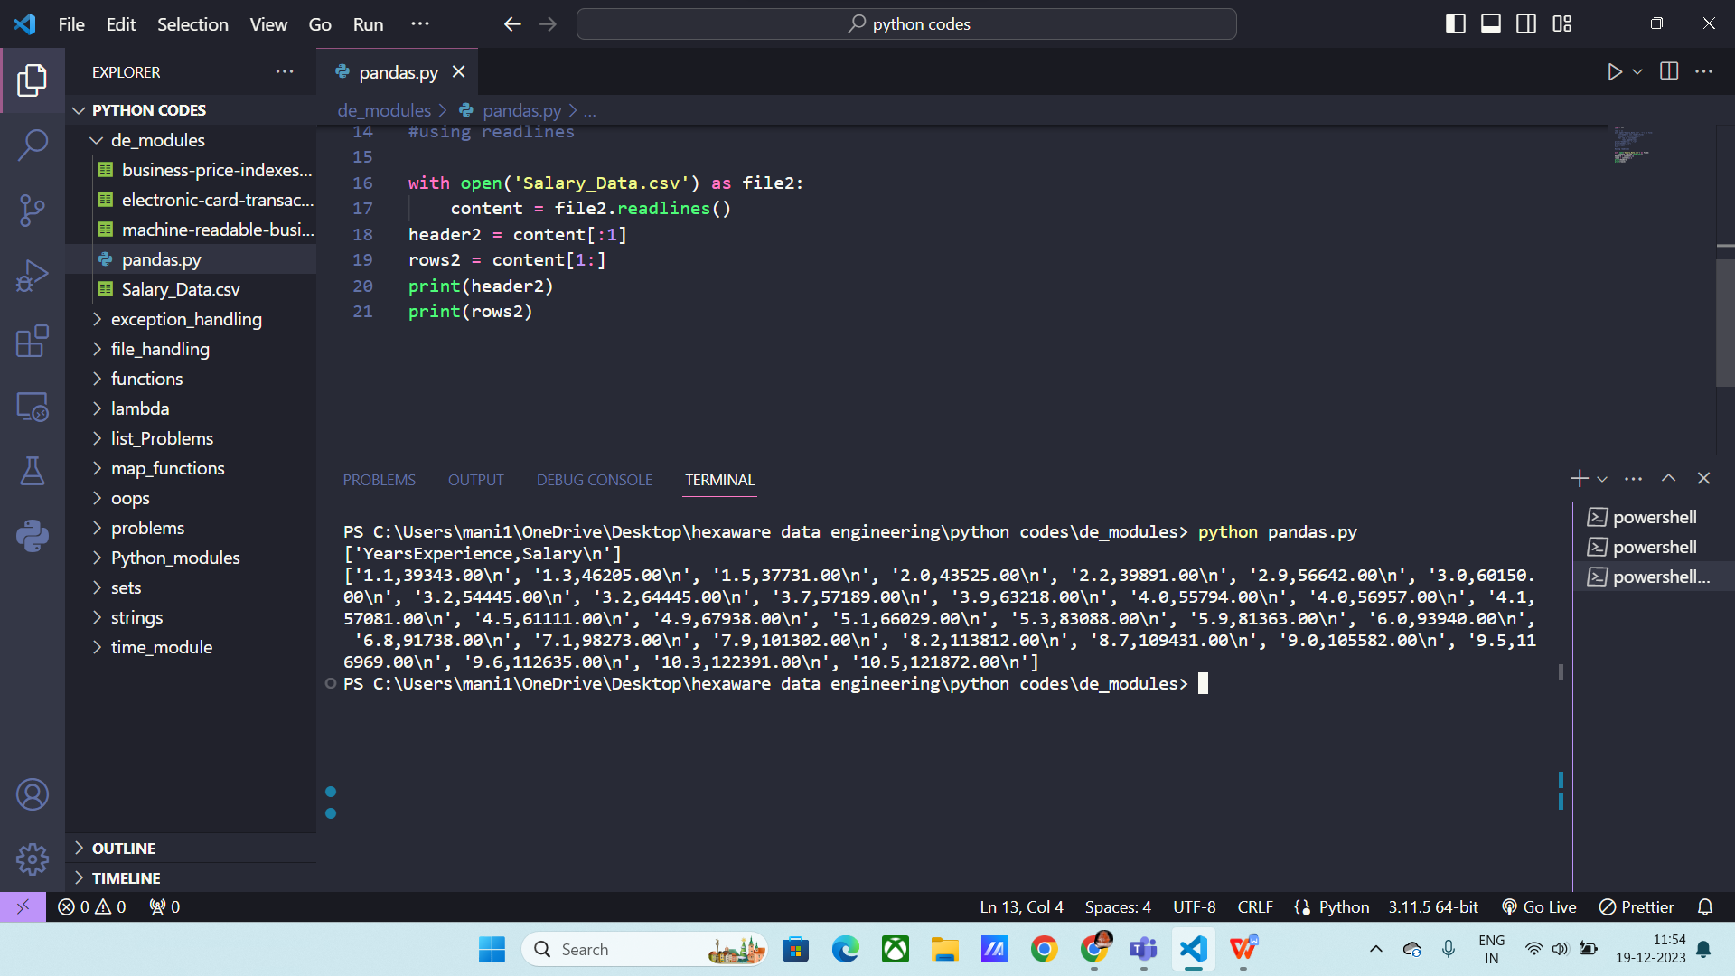

Read() using pandas:

Syntax: pd.read_csv(“file name)

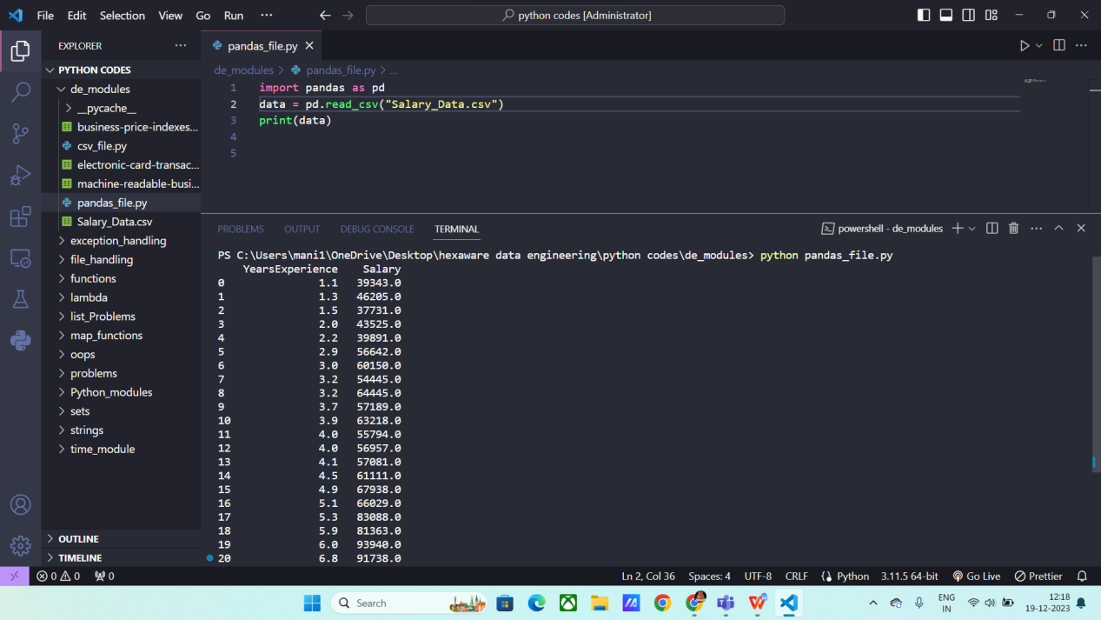

Reading columns:

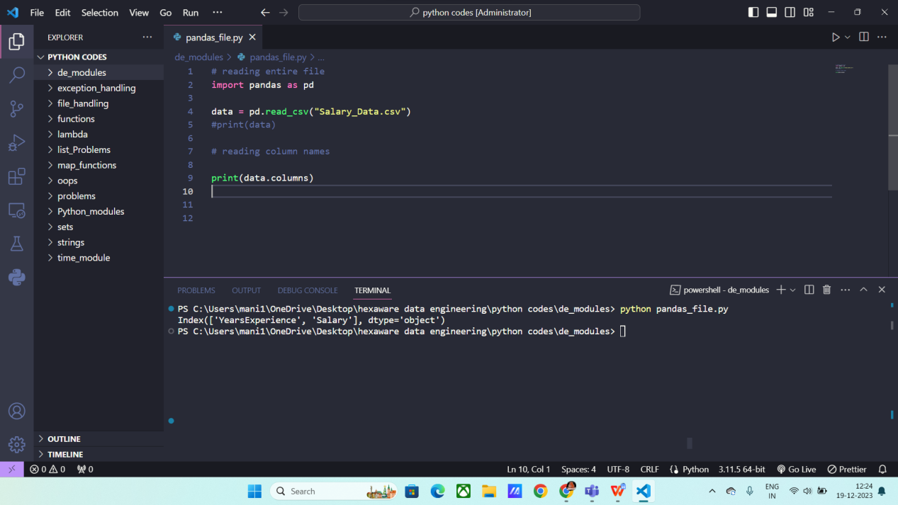

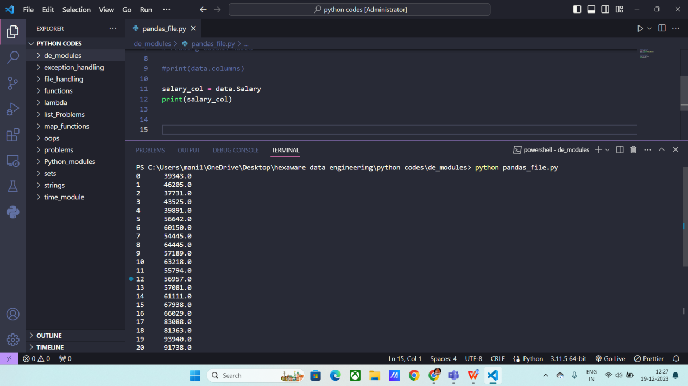

**DictReader ():** It is also an csv built in method to read the contents of a file.

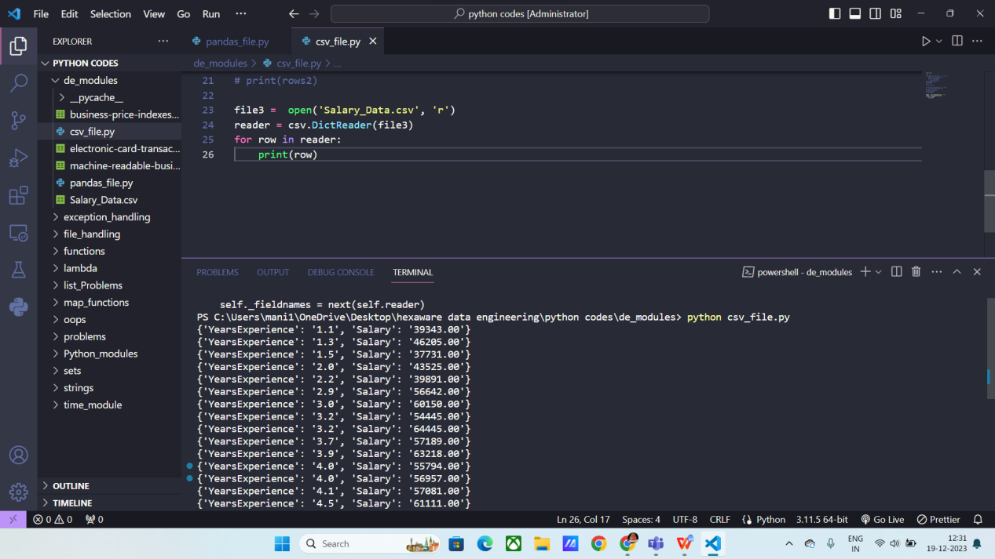

**writing data into text files using csv writer():**

We use writer() method to write into an existing file.

Write rows() to append the columns / fields and records/ observations.

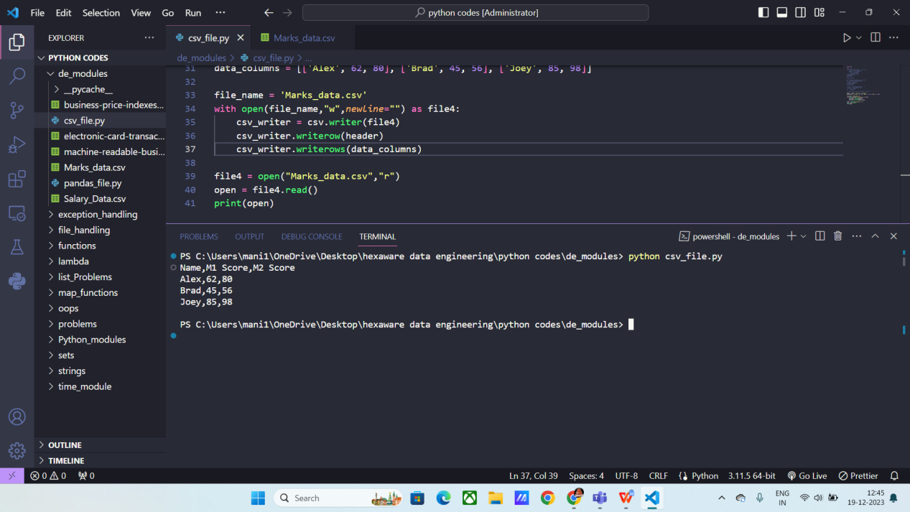

**Converting csv file into list data structure:** We use list() method to convert any data type into list.

Here first the file is opened in read mode and then converted into list and then printed.

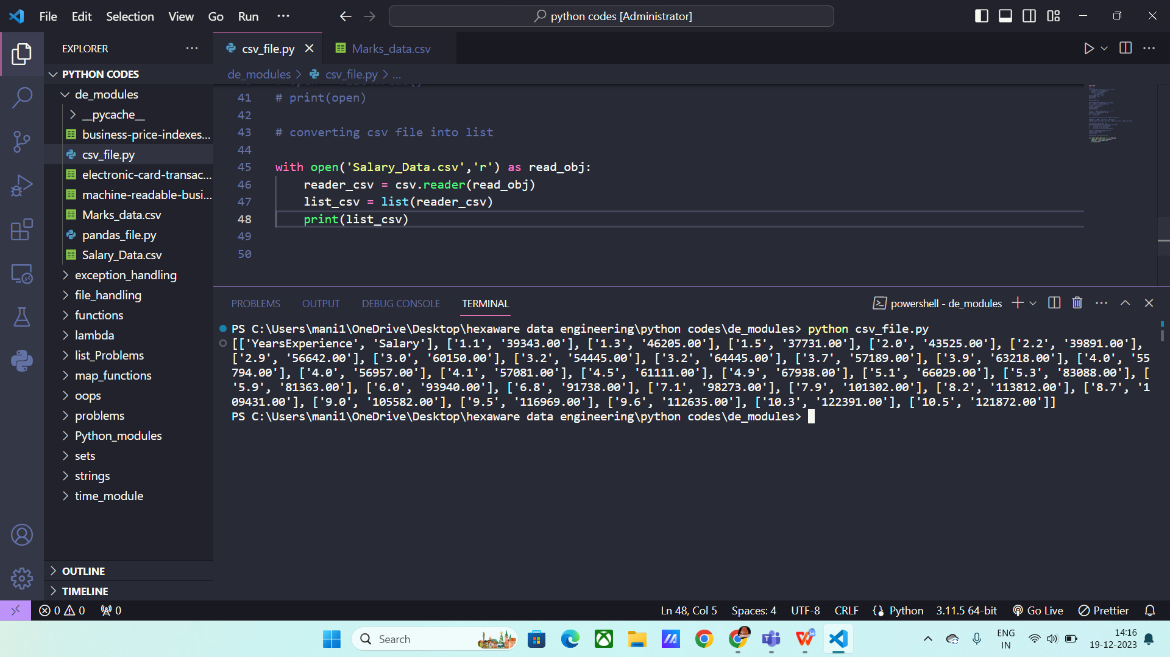

**Converting a dict into data frame:**

